Isaac Ray Shoebottom

3429069

# Section A

## A (Wine lover question):

1. First the wine is to be poured into the 5-quart glass,
2. then the 5-quart glass into the 3-quart glass so that 2 quarts are left in the 5-quart glass.
3. Pour the 3-quart glass into the 8-quart glass.
4. Then pour the 5 quarts 2 quarts into the 3-quart glass.
5. Fill the 5-quart glass.
6. Pour the 5-quart glass into the 3-quart glass. The 5-quart glass now has 4 quarts in it, the 3 quarts glass has 3 in it and the 8-quart glass has 1.
7. The 3-quart glass can be poured into the 8-quart glass so that both glasses have the same amount of liquid.

## B (Zombie Bridge question):

1. I would go with Erika, who I would leave there while I go across to return the lamp. 3 minutes will have passed.
2. I would then send Hugo and Mike together. 13 minutes will have passed.
3. They would then hand the lamp over to Erika who would then run across. 15 minutes will have passed.
4. We would then go together across again, taking 2 minutes and 17 minutes will have passed.

# Section B

## Source Code:

/** @author Isaac Ray Shoebottom (3429069) **/

public class MyFirstJavaProgram {

public static void main(String[]args) {

System.out.println("Hello World");

}

}

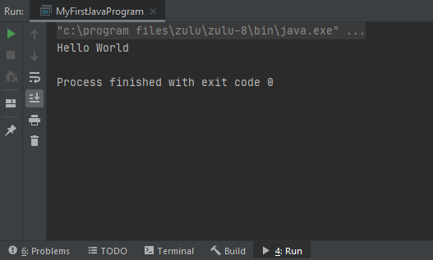

# Section C

## Source Code:

/** @author Isaac Ray Shoebottom (3429069) **/

public class MyInitials {

public static void main(String[] args) {

System.out.println("######### #### ");

System.out.println(" # ## ");

System.out.println(" # # ");

System.out.println(" # ## ");

System.out.println(" # ### ");

System.out.println(" # # ");

System.out.println(" # # ");

System.out.println(" # ## ");

System.out.println("######### #### ");

}

}

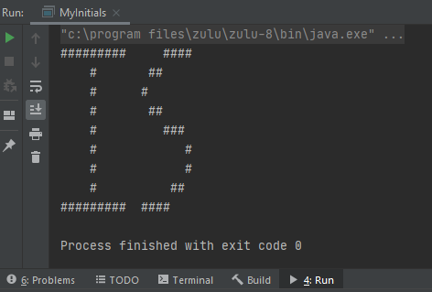

# Section D

## Source Code:

/** @author Isaac Ray Shoebottom (3429069) **/

import java.util.Scanner;

public class InputAndOutput{

public static void main(String[] args) {

Scanner sc = new Scanner(System.in);

System.out.println("My name is TOM. What is your name?");

String userName = sc.nextLine();

System.out.println("Pleased to meet you, " + userName);

System.out.println("In which program are you enrolled?");

String userEnrollment = sc.nextLine();

System.out.println("Oh? So you're " + userName + ", currently enrolled in " + userEnrollment + '!');

}

}

